6/12/2020

Nabiya Fatima BSE173011 Iqra Ishtiaq BSE173043

Software Testing

Assignment 4

Table of Contents

**Case Study** 2

**Flow Chart** 3

**Modified Condition / Decision Coverage** 3

**1. Decision Statement** 3

**1.1 Implementation** 4

**2. Decision Statement** 4

**2.1 Implementation** 4

**3. Decision Statement** 4

**3.1 Implementation** 5

**Path Predicate Expressions** 5

**Test Oracle** 5

# **Case Study**

In a programming competition the students are required to design a program that takes three numbers (a, b, c) as inputs and determine whether the equation is Quadratic or not. The standard form of Quadratic Equation is ax2+bx+c=0, where a, b, c are constants and “a” cannot be zero. The program should have a method that calculates the nature of the roots of the Quadratic equation weather the roots of the equation are Real, Equal or Imaginary using the discriminant b2-4ac. Following are the conditions that should be meet:

• If b2-4ac>0 the roots are Real and Unequal.

• If b2-4ac=0 the roots are Real and Equal.

• If b2-4ac<0 the roots are Imaginary.

The inputs for the constants a, b, c should be within the range form [0,200].

# **Flow Chart**

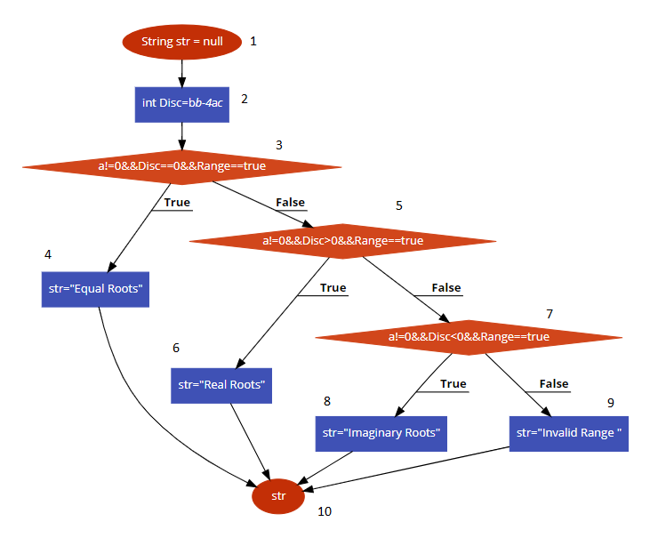

# **Modified Condition / Decision Coverage**

## **1. Decision Statement**

**a != 0 && Disc == 0 && Range==”true”**

|  |  |  |  |  |
| --- | --- | --- | --- | --- |
| **Sr.No** | **Conditions** | | | **Output** |
| **a** | **Disc=b2-4ac** | **Range** | **a != 0 && Disc == 0 && Range==true** |
| 1 | F | F | F | F |
| 2 | F | F | T | F |
| 3 | F | T | F | F |
| 4 | F | T | T | F |
| 5 | T | F | F | F |
| 6 | T | F | T | F |
| 7 | T | T | F | F |
| 8 | T | T | T | T |

## **1.1 Implementation**

|  |  |  |  |  |  |
| --- | --- | --- | --- | --- | --- |
| **Sr.No** | **Conditions** | | | | **Output** |
| **a** | **b** | **c** | **Range** | **a != 0 && Disc == 0 && Range==true** |
| 1 | 0 | 100 | 201 | False | Invalid Range |
| 2 | 0 | 100 | 1 | True | Invalid Range |
| 3 | 0 | 0 | 201 | False | Invalid Range |
| 4 | 0 | 0 | 0 | True | Invalid Range |
| 5 | -1 | 10 | 201 | False | Invalid Range |
| 6 | 1 | 1 | 0 | True | Real Root |
| 7 | -1 | 2 | -1 | False | Invalid Range |
| 8 | 1 | 0 | 0 | True | Equal Roots |

## **2. Decision Statement**

**a != 0 && Disc > 0 && Range==”true”**

|  |  |  |  |  |
| --- | --- | --- | --- | --- |
| **Sr.No** | **Conditions** | | | **Output** |
| **a** | **Disc=b2-4ac** | **Range** | **a != 0 && Disc > 0 && Range==True** |
| 1 | F | F | F | F |
| 2 | F | F | T | F |
| 3 | F | T | F | F |
| 4 | F | T | T | F |
| 5 | T | F | F | F |
| 6 | T | F | T | F |
| 7 | T | T | F | F |
| 8 | T | T | T | T |

## **2.1 Implementation**

|  |  |  |  |  |  |
| --- | --- | --- | --- | --- | --- |
| **Sr.No** | **Conditions** | | | | Output |
| **a** | **b** | **c** | **Range** | **a != 0 && Disc > 0 && a <= -1** |
| 1 | 0 | 0 | 201 | False | Invalid Range |
| 2 | 0 | 0 | 0 | True | Invalid Range |
| 3 | 0 | 100 | 201 | False | Invalid Range |
| 4 | 0 | 100 | 1 | True | Invalid Range |
| 5 | 1 | 0 | 201 | False | Invalid Range |
| 6 | 1 | 0 | 100 | True | Imaginary Root |
| 7 | 1 | 20 | -1 | False | Invalid Range |
| 8 | 1 | 1 | 0 | True | Real Root |

## **3. Decision Statement**

**a != 0 && Disc < 0 && Range==”true”**

|  |  |  |  |  |
| --- | --- | --- | --- | --- |
| **Sr.No** | **Condition** | | | **Output** |
| **a** | **Disc=b2-4ac** | **Range** | **a != 0 && Disc < 0 &&Range==True** |
| 1 | F | F | F | F |
| 2 | F | F | T | F |
| 3 | F | T | F | F |
| 4 | F | T | T | F |
| 5 | T | F | F | F |
| 6 | T | F | T | F |
| 7 | T | T | F | F |
| 8 | T | T | T | T |

## **3.1 Implementation**

|  |  |  |  |  |  |
| --- | --- | --- | --- | --- | --- |
| **Sr.No** | **Conditions** | | | | Output |
| **a** | **b** | **c** | **Range** | **a != 0 && Disc < 0 && Range==True** |
| 1 | 0 | 1 | 202 | False | Invalid Range |
| 2 | 0 | 100 | 100 | True | Invalid Range |
| 3 | 0 | 0 | 202 | False | Invalid Range |
| 4 | 0 | 0 | 100 | True | Invalid Range |
| 5 | 1 | 30 | 201 | False | Invalid Range |
| 6 | 1 | 30 | 100 | True | Real Root |
| 7 | 1 | 1 | 201 | False | Invalid Range |
| 8 | 1 | 1 | 1 | True | Imaginary Roots |

**Note**

The highlighted test cases 4,6,7,8 are sufficient for MD/DC and the test cases 1,2,3,5 are redundant.

# **Path Predicate Expressions**

|  |  |  |
| --- | --- | --- |
| **SR.No** | **Path Predicate Expression** | **Path** |
| 1. | a!=0 && Disc==0&&Range==true | 1-> 2->3->4->10 |
| 2. | a!=0 && Disc>0&& Range==true | 1-> 2-> 3->5->6->10 |
| 3. | a!=0 && Disc<0&& Range==true | 1->2->3->5->7->8->10 |
| 4. | a==0 || Range==false | 1->2->3->5->7->9->10 |

# 

# **Test Oracle**

|  |  |  |  |  |  |  |
| --- | --- | --- | --- | --- | --- | --- |
| **Sr.No** | **Inputs** | | | **Path** | **Actual Output** | **Expected Output** |
| **a** | **b** | **c** |
| 1 | 1 | 0 | 0 | 1-> 2->3->4->10 | Equal Roots | Equal Roots. |
| 2 | 1 | 1 | 0 | 1-> 2-> 3->5->6->10 | Real Root. | Real Root. |
| 3 | 1 | 1 | 1 | 1->2->3->5->7->8->10 | Imaginary Root**.** | Imaginary Root**.** |
| 4 | 1 | 2 | 0 | 1->2->3->5->7->9->10 | Invalid Range | Invalid Range |